ASSIGNMENT -I

Name: Hamza Mohammad Asim

Employee # : 2303.KHI.DEG.014

Mate: Saad Sameer Khan (2303.KHI.DEG.034)

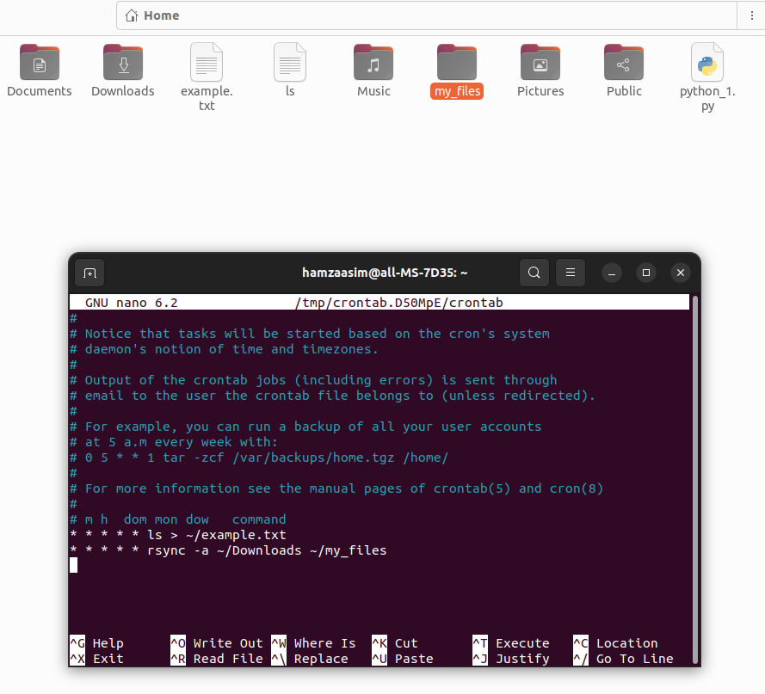

1. Used ‘crontab -e‘ to create a new cronjob. The first task I automated was to display all the files in the directory in ‘example.txt’ every minute.

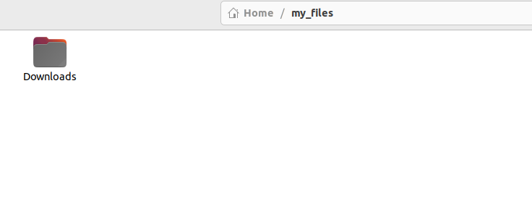

2. Used ‘rsync’ to sync all the items in ‘Downloads’ to my_files every minute.

